|  |  |  |  |
| --- | --- | --- | --- |
| 1 | | 31,200 | |
| **NUMERO DE FRONTERAS** | | **ENERGIA AGREGADA** | |
|  | | | |
| 57,863,927 | 109 | | 2,271,390 |
| INGRESO 2020 | DÍAS CERTIFICADOS 2020 | | ENERGIA RESPALDADA 2020 |
|  | | | |
| 113,196,890 | 159 | | 4,958,150 |
| INGRESO 2021 | DÍAS CERTIFICADOS 2021 | | ENERGIA RESPALDADA 2021 |

**HISTORICO REINTEGRO DDV**

|  |  |  |
| --- | --- | --- |
|  | **2020** | **2021** |
| **ENE** | - | 10.45 |
| **FEB** | - | 19.05 |
| **MAR** | - | 9.48 |
| **ABR** | - | 0.77 |
| **MAY** | 1.42 | 11.42 |
| **JUN** | 15.4 | 1.39 |
| **JUL** | 14.83 | 20.38 |
| **AGO** | 13.27 | 17.24 |
| **SEP** | - | 12.28 |
| **OCT** | - | 10.75 |
| **NOV** | - | - |
| **DIC** | 12.94 | - |

**Los valores de la tabla están en millones de COP**

**REINTEGRO MECANISMO DDV OCTUBRE 2021**

|  |  |  |  |  |  |
| --- | --- | --- | --- | --- | --- |
| FECHA | TIPO DIA | CANTIDADES RESPALDO | PRECIO PONDERADO USD | TRM | PNETO |
| 2021-10-01 | Viernes | 31,197 | 5.98 | 3,784.44 | 632,592 |
| 2021-10-02 | Sábado | 31,197 | 5.98 | 3,784.44 | 632,592 |
| 2021-10-03 | Domingo - Festivo | 31,197 | 5.98 | 3,784.44 | 632,592 |
| 2021-10-04 | Lunes | 31,197 | 5.98 | 3,784.44 | 632,592 |
| 2021-10-05 | Martes | 31,197 | 5.98 | 3,784.44 | 632,592 |
| 2021-10-06 | Miércoles | 31,197 | 5.98 | 3,784.44 | 632,592 |
| 2021-10-07 | Jueves | 31,197 | 5.98 | 3,784.44 | 632,592 |
| 2021-10-08 | Viernes | 31,197 | 5.98 | 3,784.44 | 632,592 |
| 2021-10-09 | Sábado | 31,197 | 5.98 | 3,784.44 | 632,592 |
| 2021-10-10 | Domingo - Festivo | 31,197 | 5.98 | 3,784.44 | 632,592 |
| 2021-10-11 | Lunes | 31,197 | 5.98 | 3,784.44 | 632,592 |
| 2021-10-19 | Martes | 31,197 | 5.98 | 3,784.44 | 632,592 |
| 2021-10-20 | Miércoles | 31,197 | 5.98 | 3,784.44 | 632,592 |
| 2021-10-21 | Jueves | 31,197 | 5.98 | 3,784.44 | 632,592 |
| 2021-10-22 | Viernes | 31,197 | 5.98 | 3,784.44 | 632,592 |
| 2021-10-23 | Sábado | 31,197 | 5.98 | 3,784.44 | 632,592 |
| 2021-10-24 | Domingo - Festivo | 31,197 | 5.98 | 3,784.44 | 632,592 |

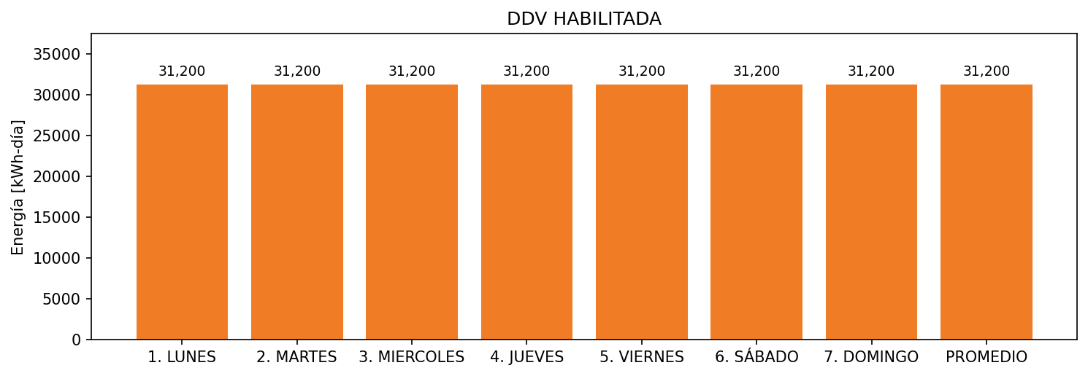

|  |  |  |  |  |  |  |  |  |  |
| --- | --- | --- | --- | --- | --- | --- | --- | --- | --- |
| **FRONTERA** | **COD SIC** | **FRT DDV** | **TIPO DDV** | **PROMEDIO** | **PRÓXIMA ACTUALIZACIÓN** | **MARGEN DE ERROR** | **ÚLTIMA PRUEBA DDV** | **DÍAS PARTICIPACIÓN** | **FECHA REFERENCIA PRÓXIMA PRUEBA DDV** |
| HOTEL ESTELAR CARTAGENA DE INDIAS | Frt26708 | Frt36998 | GPE | 31,200 | 2023-04-15 | NO APLICA | 2021-06-15 | 89.0 | 2021-12-17 |